VA Official Touts ‘Stunning’ Results Of MDMA Therapy Trial While Praising Sen. Kyrsten Sinema’s Psychedelic Knowledge

on
August 13, 2024
By
Kyle Jaeger
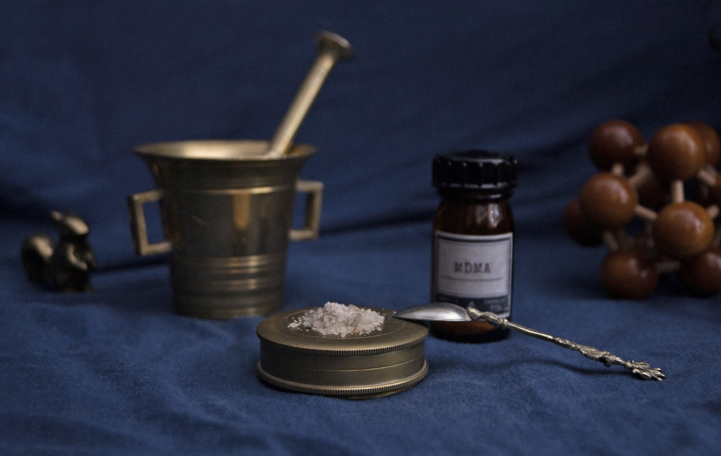
A U.S. Department of Veterans Affairs (VA) official says the agency has produced “stunning and robust results” from a first-ever clinical trial into MDMA therapy. She is also applauding Sen. Kyrsten Sinema (I-AZ), who recently visited a VA research facility, for her “knowledge of the psychedelic literature and all of the relevant issues.”
Rachel Yehuda, director of mental health at VA’s James J. Peters Veterans Affairs Medical Center, thanked Sinema, as well as VA Under Secretary for Health Shereef Elnahal, for attending an event last week where officials were able to share findings from their study on MDMA-assisted psychotherapy. This comes as the Food and Drug Administration (FDA) faces criticism from advocates and researchers after denying an application to approve the novel therapy based on separate research.
“This first randomized clinical trial at VA seems to have produced stunning and robust results, which I cannot wait to share,” Yehuda said in a LinkedIn post. “Some of our veteran research participants shared their moving stories of healing and transformation.”
“I am overwhelmed with gratitude at the support we are receiving from the United States Congress—Senators and Representatives. In a bipartisan manner,” Yehuda said, adding that Sinema was a particularly active voice in advocating for the psychedelics research.
“They get it. Senator Krysten Sinema was so highly impressive in her knowledge of the psychedelic literature and all of the relevant issues we face, that it actually blew me away,” she said.
“The VA continues to take leadership in the psychedelic arena, and it is coming from the top! The VA will fund psychedelic research, and when the time is right, move to ensure safe clinical implementation,” Yehuda, who also serves as director of the Center for Psychedelic Psychotherapy and Trauma Research at Mount Sinai, said.
Just one day before FDA declined to approve a new drug application for MDMA-assisted therapy, the VA official said she’s been asked how that decision might affect the department’s own work. She said the answer is: “Double down on the research. Keep generating the data and the cases. The nature of challenge is, well, that it is challenging. But I am optimistic.”
Bipartisan lawmakers separately staged an event at the U.S. Capitol calling for the MDMA approval by FDA and also launched an art installation memorializing military veterans who died by suicide.
Meanwhile, the U.S. House of Representatives recently approved amendments to a large-scale spending bill that would authorize VA doctors to issue medical marijuana recommendations to military veterans and support psychedelics research and access.
The Senate Appropriations Committee last week also passed report language for appropriations legislation conveying concerns about restrictions on marijuana and psychedelics research imposed by current prohibition.
Last week, FDA also withdrew a request for White House permission to conduct a study about the risks of using kratom and psychedelics amid a “rapid resurgence” of public interest in the substances. Advocates are celebrating the news after criticizing the initial request as another example of FDA “bias” against harm reduction options.
A national nonprofit drug policy reform group is separately mounting a challenge to the Drug Enforcement Administration’s (DEA) proposal to ban two psychedelic substances. Experts say the new federal restriction would be detrimental to ongoing research initiatives.

